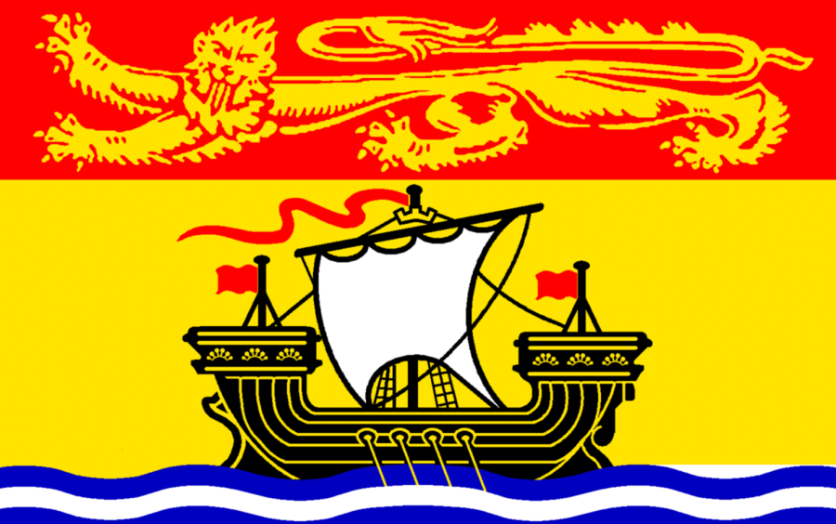

**Spring Annual General Meeting and Education Sessions**

**in conjunction with the New Brunswick Pharmacy Conference**

**Canadian Society of Hospital Pharmacists - New Brunswick Branch**

**June 10th, 2017, Delta Hotel**

**Saint John, New Brunswick**

You are invited to attend the CSHP-NB Annual General Meeting and Spring Education Sessions, **June 10th, 2017** at the **Delta Hotel in Saint John**.

The CSHP-NB program provides a total of 3 hours of education that permits attendees the opportunity to self-assign up to 3 CEUs.

**CSHP-NB is celebrating 50 years!**

CSHP-NBis pleased to provide its members with the **opportunity to attend all education sessions** on Saturday only, including those scheduled by the NBPA (see NBPA conference schedule for more information at <https://nbpharma.ca/pharmacists/conferences> ).

**Schedule of Events (Room Locations TBA)**

0930-0945 **Registration**

0945-1000 **Opening Remarks**

1000-1050  **Medical Assistance in Dying – Impact on the Role of the Pharmacist**

Diane Brideau-Laughlin and Dr. Julia Wildish

Learning Objectives

Participants will:

* Know the steps to take if they receive a request for MAiD
* Understand the role of the pharmacist in the provision of MAiD
* Understand the process for eligibility assessment for patients requesting MAiD

1100-1150 **Update on Treatment of Hepatitis C**

Dr. Meaghan O’Brien

Learning objectives

* Review current Canadian Guidelines on treatment of Hepatitis C
* Review current drug coverage of the various treatments and brief criteria for coverage
* Review main side effects and drug-drug interactions of current treatments

Continued on next page

1200-1300 **Buffet Lunch with Exhibitors**

1300-1400 **CSHP-NB Annual General Meeting**

1400-1450 **Expanded Scope of Pharmacy Practice in New Brunswick Hospitals**

Dr. Douglas Doucette and Luc Jalbert

Learning objectives

* To summarize key “pillars of evidence” for benefit of pharmacist services to patient outcomes;
* To illustrate examples of how Pharmacy Services in our respective Regional Health Authorities are working in or towards expanded scope of practice, and
* To describe next steps required to lead NB hospital pharmacists to work at full scope of practice.

1900-2030 **Past Presidents’ Banquet and Awards Gala**

(see ‘Fees’ Section for special CSHP-NB rate)





**Spring Annual General Meeting and Education Sessions**

**in conjunction with the New Brunswick Pharmacy Conference**

**Canadian Society of Hospital Pharmacists - New Brunswick Branch**

**June 10th, 2017, Delta Hotel**

**Saint John, New Brunswick**

**Registration**

Name: ___ CSHP # ____________

Address: __________________

Email: __________________

Phone # __________________

Allergies/Dietary needs: __________________

**Fees:**

**Education sessions only** (including sessions put on by both NBPA and CSHP on June 10th only)

□ **$20 CSHP members**

**\*NEW* Admission to Banquet and Awards Gala – Help celebrate CSHP-NB turning 50!**

□ **$50 (Special rate for CSHP Members only)**

**Education Sessions (Saturday June 10th) AND Banquet and Awards Gala**

□ **$70 (Special rate for CSHP Members only)**

**Note: non-CSHP members must register via New Brunswick Pharmacist Association process and pay the NBPA fees.** <https://nbpharma.ca/pharmacists/conferences>

Continued on next page

**Payment:**

**Completed registration forms are due by June 2nd 2017**

Registration forms may be completed and given (along with payment – cash or cheque) to local representatives at the following sites:

**Dan Landry Haley Brennan**

Dr. Georges-L.-Dumont University Hospital Centre Moncton Hospital

**Holly Glennie Lindsay Lord Doucet**

Saint John Regional Hospital Chaleur Regional Hospital

**Kristin Armstrong**

Dr. Everett Chalmers Regional Hospital

Registrants **not** situated at the sites above may fax/mail/email their registration forms to

Haley at the Moncton hospital. These participants **only** may pay at the door on June 10th.

**Haley Brennan**

Pharmacy Department  
Moncton Hospital

135 MacBeath Ave  
Moncton, NB

E1C 6Z8

Fax : 506-857-5540  
Email: [haley.brennan@horizonnb.ca](mailto:haley.brennan@horizonnb.ca)